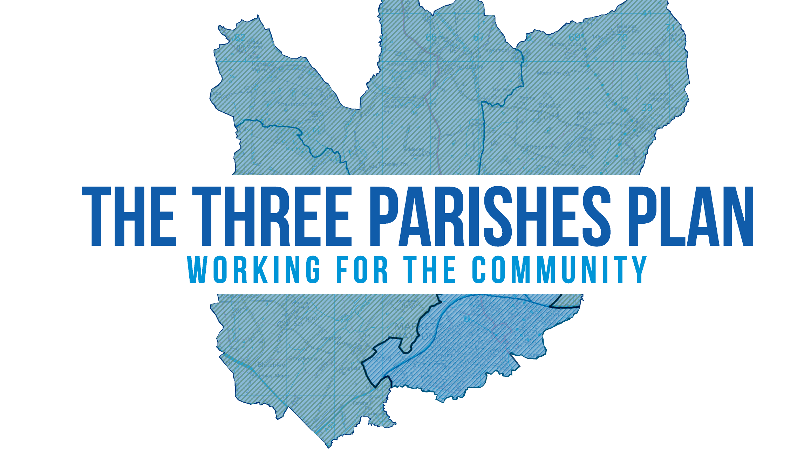

The Three Parish Neighbourhood Plan

Evidence Base Review

June 2019

- Introduction

Neighbourhood Plans are required to sit within the framework of national, regional and local planning policies, and to be in general conformity with those policies.

The Three Parishes Neighbourhood Plan is at an early stage of its preparation. The three parishes of Adderley, Moreton Say and Norton in hales have come up with a steering group to prepare a NP covering the three parishes. The evidence review document examines the existing evidence base to ensure that it is fit for purpose to support any policy direction the NP will take and to ensure that any critical gaps can be addressed before a draft NP is produced.

The Evidence Review document forms an important background document to the Neighbourhood Plan and should be used as a key point of reference for members of the Neighbourhood Plan Steering Group. It has been prepared as a “live” working document and will continue to be reviewed and updated throughout the preparation of “The Three Parishes Neighbourhood Plan”.

It is very important that the Neighbourhood Plan is underpinned by evidence that provides reasoned justification for the planning policies.

The Planning Practice Guidance states that “while there are prescribed documents that must be submitted with a neighbourhood plan or Order there is no ‘tick box’ list of evidence required for neighbourhood planning. Proportionate, robust evidence should support the choices made and the approach taken. The evidence should be drawn upon to explain succinctly the intention and rationale of the policies in the draft neighbourhood plan or the proposals in an Order”.
Paragraph 040 Reference ID: 41-040-20160211

Shropshire Council should share relevant evidence, including that gathered to support its own plan-making, with a qualifying body. The steering group is advised to approach Shropshire Council and discuss what kind of information is available for the Parish to inform their neighbourhood plan.

- Methodology
The approach taken in this evidence review involved examining planning documents relevant to The Three Parish Neighbourhood Plan. As the neighbourhood planning documents are required to be in conformity to the strategic policies of the development plan, evidence sources were largely from the Shropshire Local Plan evidence base. The relevant development plan for Shropshire involves the Core Strategy, SAMDev, and adopted neighbourhood plans. Since the LA is carrying out a review of the Local Plan, this evidence review has started examining data underpinning the emerging Local Plan. As this is a live document, the steering group is encouraged to continue reviewing and updating the document throughout the preparation of “The Three Parishes Neighbourhood Plan” as new and up to date evidence emerges.
In order to assess and draw conclusions as well as coming up with planning objectives and possible policies for the neighbourhood plan, it is prudent to group the evidence in topics or policy themes. These can be used to group policies in the neighbourhood plan. The suggested policy topics are:
- Housing
- Economy
- Natural environment
- Connections (highways, broadband)
- Built environment and Heritage
- Community facilities and wellbeing
The Three Parish NP steering group has carried out some open forum meetings in all three Parishes during March 2019. Participants were given the choice of entering their comments either online or by filling and submitting a paper form. Findings from these surveys have also been incorporated in this document as part of the evidence gathered.
During the open forum events, evening meetings were carried out in all three parishes. This allowed residents to give their views and also ask questions regarding the neighbourhood planning process. We produced Parish Profiles for all three parishes and this was based largely from the 2011 census. The profiles cover the characteristics of people and households in the Three Parish NP area. The evidence review alongside these parish profiles provided the basis to analyse the current situation of the neighbourhood area.
The evidence review will help identify the current evidence base to produce the neighbourhood plan and also identify areas where further assessments need to be carried out. The document concludes with some recommendations on options the steering group can consider in taking the neighbourhood plan to the next stage.
In terms of next steps, having identified the issues to address in the neighbourhood plan through public consultations, open forums, parish profiles and evidence review, the steering group will then need to develop a vision and come up with some aims and objectives. Then policy options can be generated to address the vision and objectives.

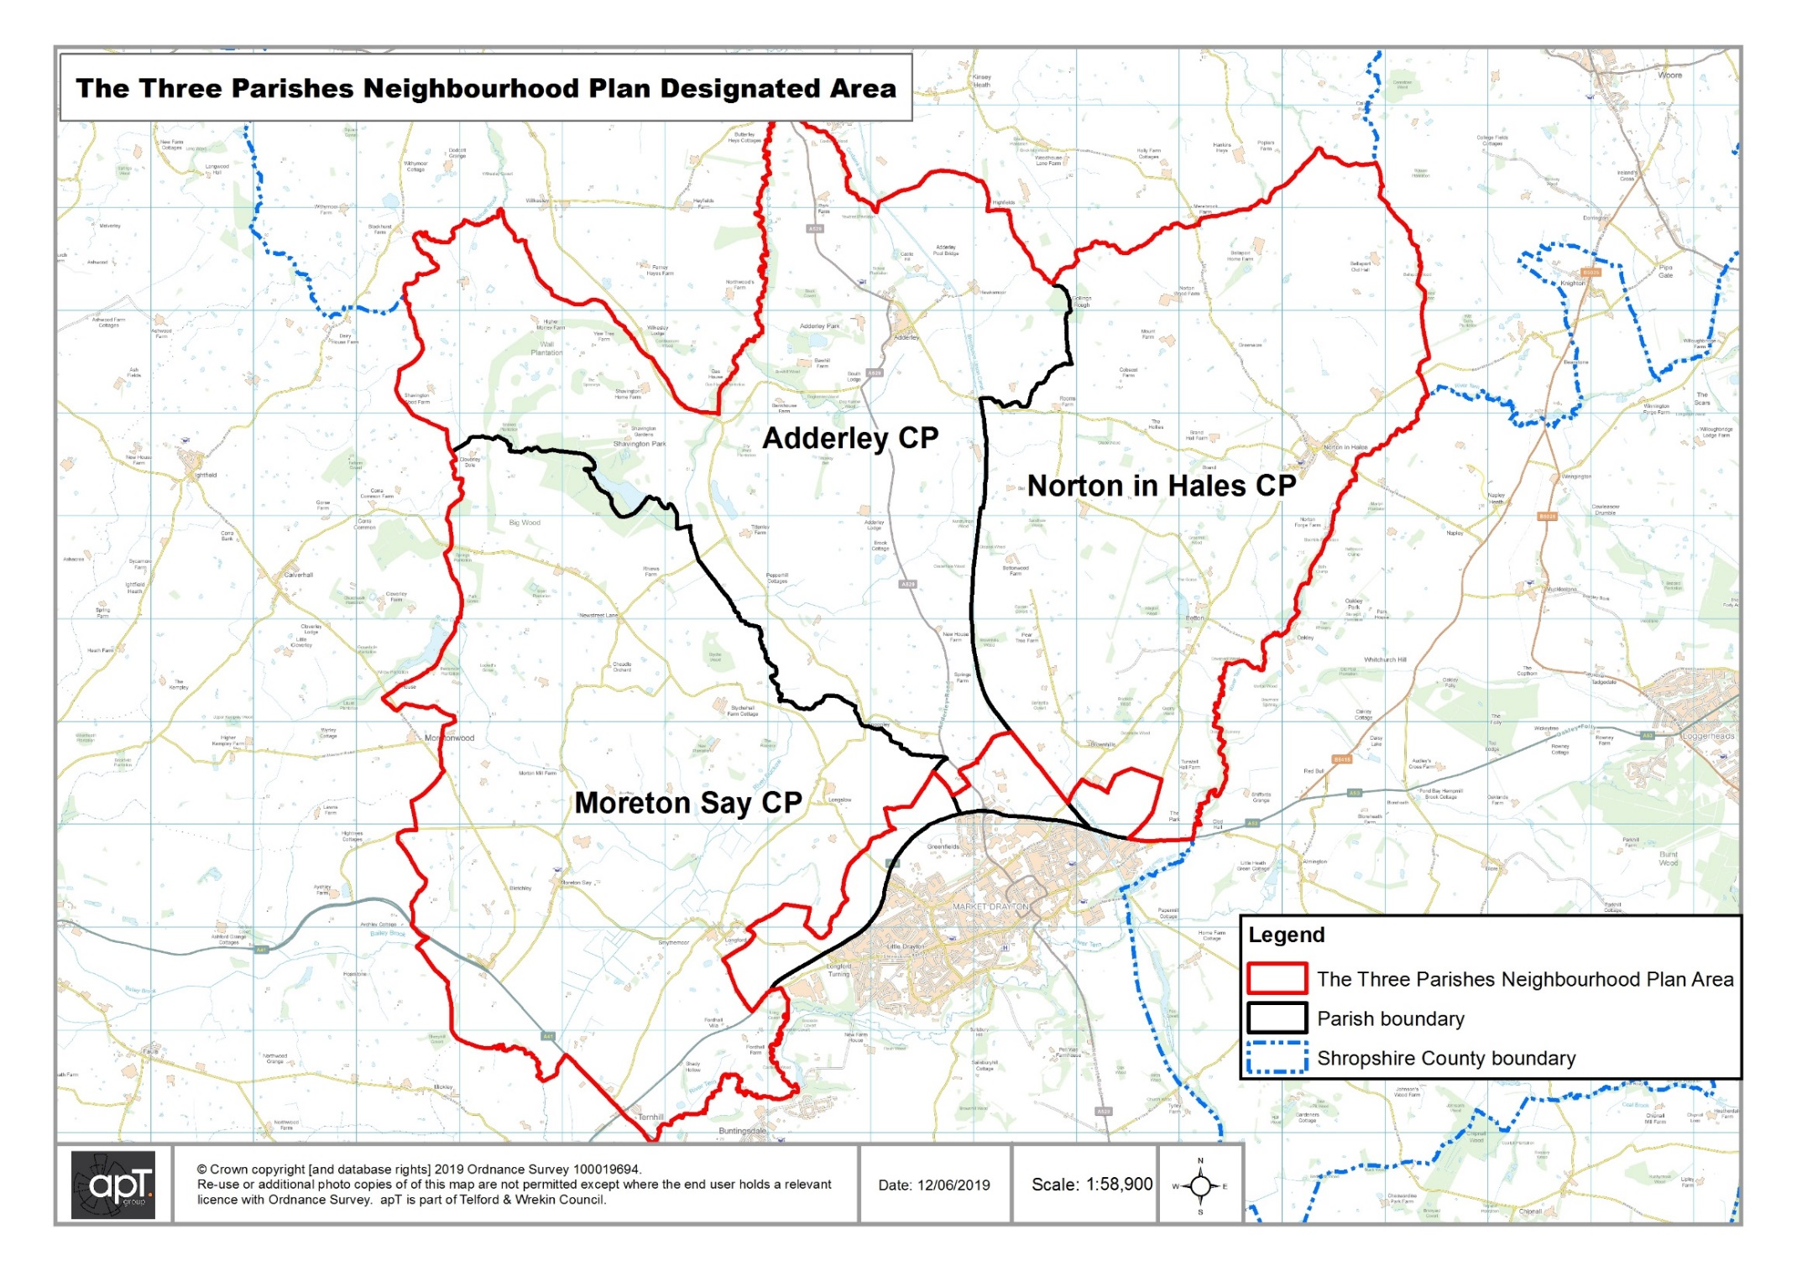
- Evidence Review
THEME: Housing
Evidence Document | Brief summary | Comments
Adopted Core Strategy | The Core Strategy Development Plan Document (DPD) was adopted on 24 February 2011.The document sets out the strategic planning policy for Shropshire, including a 'spatial' vision and objectives. It also sets out a development strategy identifying the level of development expected to take place in Shropshire up until 2026.  The Core Strategy can be accessed via this web link - https://shropshire.gov.uk/media/8534/core-strategy.pdf | The Core Strategy embodies an innovative approach to development in Shropshire and aims to deliver more sustainable places at all levels and in both urban and rural settings.  It is within the Core Strategy Policy CS4 where we see the introduction of the concept of community hubs and community clusters. Community Clusters are comprised of two or more small settlements, where the combined settlements offer a range of services contributing to a sustainable community. In this case development will only be allowed within (and not between) settlements and for planning purposes, the countryside between the settlements is not part of the cluster. These areas are protected by policy CS5 on Countryside and Green Belt. Though there is no green belt land in the Three Parish NP area, the majority of the area will fall in the countryside category and future policies in the neighbourhood plan must will be expected to be compliant with this policy.  It must be noted that the date of adoption predates the introduction of neighbourhood development plans or the National Planning Policy Framework (2012) so some policies may not be consistent with more recent national policy.
Shropshire Council Site Allocations and Management of Development (SAMDev) Plan | The Site Allocations and Development Management (SAMDev) Plan sets out proposals for the use of land and policies to guide future development in order to help to deliver the Vision and Objectives of the Core Strategy for the period up to 2026.  The SAMDev Plan also sets out further detailed policies for the management of new development across Shropshire to complement the policies already adopted in the Shropshire Core Strategy, and to provide a greater level of detail on a number of planning issues.  https://shropshire.gov.uk/media/8503/samdev-adopted-plan.pdf | The identification of Community Hubs and Cluster settlements and their settlement policies was based primarily on the aspirations for those communities as expressed by their Parish Councils. There was also regard to the evidence base and information and views from the promoters of sites, residents and other stakeholders.  In recognition of the fact that the needs of communities change over time, Core Strategy Policy CS4 left the door open for communities that might want to be considered as Community Hubs or Community Cluster settlements to ‘opt in’ and be formally designated at a later date through reviews of the Local Plan. Policy MD1 clarifies that the process relating to this, ahead of a review of the Local Plan, is through a combination of formal Community-led Plan or Neighbourhood Plan preparation or review, Parish Council proposal and Shropshire Council agreement. These communities will only be formally designated as Community Hubs or Community Clusters through a review of the Local Plan. The Plan contains settlement policies which are grouped by areas that reflect approximate functional zones of influence (known as ‘Place Plans’) of each of the 18 market towns and key centres.  Market Drayton provides focus for development in the north eastern part of the County and Adderley is a community Hub with a housing guideline of around 14 dwellings over the period to 2026. This will be delivered through infilling, groups of houses and conversions which may be acceptable on suitable sites within the development boundary identified on the Policies Map.  Policy S11.2 (ix) classifies Moreton Say as a community cluster and will provide limited future housing growth of approximately 20 dwellings over the period to 2026 together with settlements of Bletchley, Longford, and Longslow. This will be delivered through infilling, groups of houses and conversions on suitable sites within the development boundary for the village of Moreton Say.  The majority of the land in the Three Parishes falls in the countryside and Policy MD7a manages housing development in the countryside. Suitably designed and located exception site dwellings and residential conversions will be positively considered where they meet evidenced local housing needs and other relevant policy requirements. In the case of market residential conversions, requiring planning permission, the conversion of buildings to open market use will only be acceptable where the building is of a design and form which is of merit for its heritage/ landscape value, minimal alteration or rebuilding is required to achieve the development and the conversion scheme would respect the significance of the heritage asset, its setting and the local landscape character.
Emerging Shropshire Local Plan Review : Consultation on Preferred Sites (November 2018) | Shropshire are currently undertaking a Local Plan Review extending the plan period to 2036. The Local Plan will support local growth by generating certainty for investment in local development and infrastructure and will achieve this by providing a policy framework that establishes an up to date and objective assessment of development needs and supports sustainable development in Shropshire during the period to 2036 | Moreton Say, Adderley and Norton in Hales are proposed as community clusters and any location outside these will be regarded to be ‘countryside’ for planning policy purposes, where new development is strictly controlled in accordance with national and local planning policies.  The Market Drayton Place Plan Area – Moreton Say, Adderley and Norton in Hales are proposed as community clusters in the Market Drayton Place Plan Area. Settlements can opt in or opt out as community clusters. Development within community clusters will be managed through a criteria based policy and this draft policy was consulted upon between October and December 2017.  The criteria based policy will manage development within Community Cluster settlements. Reflecting the types of development that are consistent with the criteria in this policy, it is not considered necessary to identify development boundaries; residential development guidelines; or to allocate sites in the Community Cluster settlements. The policy will allow for suitable small scale infill sites, or through the conversion of existing buildings. The policy does not preclude drawing settlement boundaries or allocating small sites.  The Local Plan Review will seek to achieve balanced housing growth within Market Drayton through the provision of around 1,200 dwellings between 2016 and 2036.  The Three Parish Neighbourhood Plan will need to be in compliance with this emerging Local Plan in the event that it is adopted after the Local Plan adoption. The Neighbourhood Plan is required to be in general conformity with the strategic policies of the development plan but it is prudent to also check the NP against the emerging Local Plan.
Hierarchy of Settlements (November 2018) | Due to the size and diversity of Shropshire and its settlements, it is considered beneficial to produce a settlement hierarchy. A settlement hierarchy is a way of categorising settlements, based upon an assessment of specific and consistent criteria. This information will in part, inform decisions on locations of development.  The Hierarchy of Settlements document provides a summary and presents the conclusions reached in the settlement hierarchy assessment of Shropshire. The purpose of this settlement hierarchy is to review how settlements in Shropshire function, which will inform decisions on future locations of development. It also forms part of the evidence base for Local Plan review.  Hierarchy of Settlements | The first stage of the assessment involved the identification of those settlements suitable for inclusion within it using an agreed methodology. This identified around 550 ‘recognisable named settlements’ in Shropshire. The next stage involved screening all the settlements with those settlements which are unlikely to offer a range of facilities and services being screened out. Of the three parishes, Adderley and Norton in Hales were screened in whilst Morton Say was screened out.  The remaining settlements were then assessed and the final stage of the assessment utilised the outputs of the earlier stages of assessment in order to rank and categorise settlements by their functionality.  Both Norton in Hales and Adderley parishes were categorised in “other rural settlements”. The settlements within this category provide a more limited combination of services and facilities; public transport links (some of which operate regularly through peak travel times); significant employment opportunities; and high speed broadband.  Whilst this combination of specific services and facilities; public transport links; high speed broadband; and significant employment opportunities varies, it is generally considered that resident communities are at least partially reliant upon other settlements (either within this same category, due to the differing offer amongst them; or settlements that are higher in the hierarchy) to meet certain day-to-day needs.  Settlements within this category will be classified as Countryside.  It is recommended for the steering group to request information/data that relates to the Three Parish neighbourhood plan area from Shropshire Council.

THEME: Economy
Evidence Document | Brief summary | Comments
Adopted Core Strategy | The Core Strategy Development Plan Document (DPD) was adopted on 24 February 2011.The strategy sets out the strategic planning policy for Shropshire, including a 'spatial' vision and objectives. It also sets out a development strategy identifying the level of development expected to take place in Shropshire up until 2026.  The Core Strategy can be accessed via this web link - https://shropshire.gov.uk/media/8534/core-strategy.pdf | The characteristics of Shropshire’s labour force and economy, in part, reflect the rural nature of the County, with a traditional dependence on agriculture and related sectors and comparatively low employment in knowledge based industries. Shropshire has a predominantly small business economy, with 87% of businesses employing 10 or fewer staff.  The Shropshire Union Canal runs through the Three Parish Neighbourhood Plan area.  It must be noted that the date of adoption predates the introduction of neighbourhood development plans or the National Planning Policy Framework (2012) so some policies may not be consistent with national policy.
Shropshire Council Site Allocations and Management of Development (SAMDev) Plan | The Site Allocations and Development Management (SAMDev) Plan sets out proposals for the use of land and policies to guide future development in order to help to deliver the Vision and Objectives of the Core Strategy for the period up to 2026.  The SAMDev Plan also sets out further detailed policies for the management of new development across Shropshire to complement the policies already adopted in the Shropshire Core Strategy, and to provide a greater level of detail on a number of planning issues.  https://shropshire.gov.uk/media/8503/samdev-adopted-plan.pdf | Policy MD1 provides guidance on the scale and distribution of development. It provides an approximate proportional split between Shrewsbury (25%), the Market Towns and other Key Centres (40%), and the rural areas, including the  Community Hubs and Cluster Settlements (35%). Adderley is under Market Drayton community Hub and Morton Say is categorised to be under a community cluster.
Emerging Shropshire Local Plan Review : Consultation on Preferred Sites (November 2018) | Shropshire are currently undertaking a Local Plan Review extending the plan period to 2036. The Local Plan will support local growth by generating certainty for investment in local development and infrastructure and will achieve this by providing a policy framework that establishes an up to date and objective assessment of development needs and supports sustainable development in Shropshire during the period to 2036 | The Local Plan Review will seek to achieve balanced employment growth within Market Drayton through the provision of around 13 hectares of employment land between 2016 and 2036.  The document states that around 35 hectares of employment provision has already been provided through allocations in the SAMDev Plan and other employment commitments. Subject to an employment land review it is considered this level of provision is sufficient to meet the needs of the local community therefore there is no requirement to identify any additional employment land in market Drayton.

THEME: Natural Environment
Evidence Document | Brief summary | Comments
Adopted Core Strategy | The Core Strategy Development Plan Document (DPD) was adopted on 24 February 2011.  The strategy sets out the strategic planning policy for Shropshire, including a 'spatial' vision and objectives. It also sets out a development strategy identifying the level of development expected to take place in Shropshire up until 2026.  The Core Strategy can be accessed via this web link - https://shropshire.gov.uk/media/8534/core-strategy.pdf | The Core Strategy embodies an innovative approach to development in Shropshire and aims to deliver more sustainable places at all levels and in both urban and rural settings  The great diversity of underlying rock types means that Shropshire possesses one of the richest and most varied landscapes in England. The countryside ranges from the gently undulating landscape in the north through the low lying fertile valleys of the meandering River Severn and its tributaries to the distinct hills and open, windswept moorlands of the south; Shropshire’s high quality natural and built environment is one of its greatest assets, attracting investment and boosting Shropshire’s image as a tourist destination, as well as playing a key role in community health and wellbeing.  Policy CS17 (Environmental Networks) states that Development will identify, protect, enhance, expand and connect Shropshire’s environmental assets, to create a multifunctional network of natural and historic resources.  It must be noted that the date of adoption predates the introduction of neighbourhood development plans or the National Planning Policy Framework (2012) so some policies may not be consistent with national policy.
Shropshire Council Site Allocations and Management of Development (SAMDev) Plan | The Site Allocations and Development Management (SAMDev) Plan sets out proposals for the use of land and policies to guide future development in order to help to deliver the Vision and Objectives of the Core Strategy for the period up to 2026.  The SAMDev Plan also sets out further detailed policies for the management of new development across Shropshire to complement the policies already adopted in the Shropshire Core Strategy, and to provide a greater level of detail on a number of planning issues.  https://shropshire.gov.uk/media/8503/samdev-adopted-plan.pdf | The changing needs and effects of agricultural and other related businesses in the countryside are a particular local issue, in particular the impacts of large scale agricultural buildings. General sustainable design criteria and development management considerations are as relevant to this type of development as other proposals in the countryside and the Plan seeks to balance the needs of the countryside as a working environment with its role as a place to live and enjoy. The policy defines the primary considerations that will be taken into account in considering agricultural development proposals which require planning consent.  Policy MD12 sets out in detail the level of protection offered to Shropshire’s natural assets. Natural assets include: biodiversity and geological features; trees, woodlands and hedges in both rural and urban settings; the ways in which the above combine and connect to create locally distinctive and valued landscapes, including the Shropshire Hills Area of Outstanding Natural Beauty and the contribution all of the above make to visual amenity.  There is an opportunity to protect to protect green areas or open spaces against development where they are of particular importance to local communities by designating them as Local Green Spaces.
Shropshire Landscape Character Assessment (2006) | Landscape character assessment (LCA) is the process of identifying and describing variation in character of the landscape. The Shropshire LCA document identifies and explains the unique combination of elements and features that make landscapes distinctive by mapping and describing character types and areas.  Landscape character is determined by six elements – Geology, Landform, Soils, Settlement, Tree Cover and Land Use - each of which can be represented in different ways via a series of different ‘attributes’. In Shropshire a broad range of attributes are present for each of the six elements.  In Shropshire 27 different landscape types can be recognised.  Shropshire Landscape Character Assessment (2006) | There are a number of landscape types which fall within the Three Parish Plan boundary and the main types are:  Settled pastoral farmlands – These are lowland agricultural landscapes which are located mainly in the northern and western parts of the county and are mainly located centrally in the Three Parish NP. One of the defining characteristics of this landscape type is that they are heavy, often poorly drained soils and have traditionally be associated with livestock farming.  Principal timbered farmlands - This landscape type occurs throughout much of Shropshire, with notable concentrations along the northern boundary with Cheshire, and to the south of Shrewsbury. They are predominantly rolling lowland landscapes, with occasional steeply undulating valley sides, and are characterised by a mosaic of agricultural land. In the Three Parish NP area this is located to the western side of the neighbourhood area.  Timbered pastures - Occurring only in the extreme north-eastern corner of Shropshire, in the area around the village of Woore, this is a lowland landscape of rolling glacial tills, where the heavy overlying soils support medium intensity dairy farming.  A number of blocks of ancient woodland, widespread wet flushes and numerous small field ponds, many of which probably occupy former marl pits, add further ecological value. The nature of the tree cover also plays an important role in structuring the landscape, creating filtered views and a small-medium scale.  This landscape is also characterised by varied field systems and a complex settlement pattern of dispersed farmsteads and wayside cottages with occasional villages.
Strategic Flood Risk Assessment | A Strategic Flood Risk Assessment (SFRA) looks at flood risk at a strategic level on a local planning authority scale. The National Planning Policy Framework (NPPF) requires local planning authorities to appraise the risk of flooding in their areas by undertaking an SFRA.  The Strategic Flood Risk Assessment (SFRA) Level 1 2018 document was created with the purpose of supporting the production of the Council’s Local Plan Review. This will provide an understanding of the risk from all types of flooding across Shropshire, and to present clear and robust evidence. It will also provide useful information to inform future Infrastructure Planning and Neighbourhood Plans.  Strategic Flood Risk Assessment | Canals do not generally pose a direct flood risk as they are a regulated waterbody. There are three canals in Shropshire including Shropshire Union Canal.  The Shropshire Union Canal enters Shropshire in the north-east of the County at Knighton. It travels north-west through Market Drayton and out of the northern boundary of Shropshire just north of Adderley. The Shropshire Union canal crosses the River Tern near Market Drayton. There has been one overtopping incident on the Shropshire Union Canal in 1839 due to heavy rain. There have been two breaching incidents, in 1971 due to vandalism at Market Drayton storm weir, and the other in 2000 at Audlem/ Hawkes Moor due to culvert failure.  In terms of flood zones, The Three Parishes neighbourhood area is predominantly located outside of any flood risk zones. The Rivers Ducklow and Tern cross through the area and their river lengths are in flood zone 3, meaning that land has a high probability of flooding.
Water Cycle Study 2014 | Shropshire Council has commenced work on a Water Cycle Study to inform the Local Plan Review. The Shropshire Water Cycle Study was commissioned to assess the impact of future development on the water environment and water infrastructure. It identifies infrastructure and environmental capacity constraints in key centres throughout Shropshire, in relation to suggested levels of housing and employment development.  The study includes identification of the sources of flooding and provides recommendations for the most suitable locations for development with regard to the level of risk (i.e. north, south, east, or west of each settlement). It also identifies any actions that need to be taken to support development, particularly in relation to infrastructure upgrades. | There is a need to assess any outcomes and recommendations of the water cycle study and see how they can feed in the neighbourhood plan process especially the effect development will have on water supply, wastewater collection and wastewater treatment.
Landscape and Visual Sensitivity Study | This study assesses the landscape around all the settlements identified for growth in the Local Plan Review. It looks at landscape character and visual amenity separately and identifies how sensitive each is to change caused by housing and employment development.  Landscape and Visual Sensitivity Study | The list of 66 settlements to be assessed was provided by Shropshire Council. This includes the ‘Strategic Centre’ of Shrewsbury which is the top tier of the settlement hierarchy in the Local Plan, five ‘Principal Centres’ and the 11 ‘Key Centres’ as well as the 40 smaller settlements which are identified as ‘Potential Community hubs’ in the Local Plan and four ‘Proposed Strategic Sites’.  The list does not include the whole of the Three Parish Plan NP area but areas just outside to the northern boundary of Market Drayton. The assessments include the settlements of Longford, Brownhills and Longslow.  The landscape is gently rolling and is dominated by pastoral agriculture and horse culture with hedgerow trees and scattered water features. It encourages to retain and respect the setting of the canal which forms a strong visual feature.  In term of landscape sensitivity, this is an intensively farmed landscape of weakened character with sparse natural features and poor connectivity. The potential to accommodate new development and mitigation combined with the distribution of sensitive receptors means the overall sensitivity of the landscape to change arising from new housing is medium-low and to employment is medium.

THEME: Built environment and Heritage
Evidence Document | Brief summary | Comments
Adopted Core Strategy | The Core Strategy Development Plan Document (DPD) was adopted on 24 February 2011.  The strategy sets out the strategic planning policy for Shropshire, including a 'spatial' vision and objectives. It also sets out a development strategy identifying the level of development expected to take place in Shropshire up until 2026.  The Core Strategy can be accessed via this web link - https://shropshire.gov.uk/media/8534/core-strategy.pdf | The Core Strategy embodies an innovative approach to development in Shropshire and aims to deliver more sustainable places at all levels and in both urban and rural settings.  Shropshire possess a rich and important historic environment. The richness of Shropshire’s historic environment is reflected in the number of designated heritage assets.  CS17 aims to deliver high quality, sustainable tourism, and cultural and leisure development. It supports appropriate regeneration schemes and tourism development proposals that seek to enhance the economic, social and cultural value of canals including Shropshire Union Canal.  It must be noted that the date of adoption predates the introduction of neighbourhood development plans or the National Planning Policy Framework (2012) so some policies may not be consistent with national policy.
Shropshire Council Site Allocations and Management of Development (SAMDev) Plan | The Site Allocations and Development Management (SAMDev) Plan sets out proposals for the use of land and policies to guide future development in order to help to deliver the Vision and Objectives of the Core Strategy for the period up to 2026.  The SAMDev Plan also sets out further detailed policies for the management of new development across Shropshire to complement the policies already adopted in the Shropshire Core Strategy, and to provide a greater level of detail on a number of planning issues.  https://shropshire.gov.uk/media/8503/samdev-adopted-plan.pdf | Policy MD13 sets out specific guidance on the protection of Shropshire’s historic environment, including the requirements that need to be met for those development proposals which are likely to have an impact on the significance, including the setting, of a heritage asset.  Policy MD2 requires new development to respect, enhance or restore the historic context of buildings. The Shropshire Historic Environment Record sets out Shropshire’s non-designated heritage assets.

THEME: Community facilities and wellbeing
Evidence Document | Brief summary | Comments
Adopted Core Strategy | The Core Strategy Development Plan Document (DPD) was adopted on 24 February 2011.  The strategy sets out the strategic planning policy for Shropshire, including a 'spatial' vision and objectives. It also sets out a development strategy identifying the level of development expected to take place in Shropshire up until 2026.  .  The Core Strategy can be accessed via this web link - https://shropshire.gov.uk/media/8534/core-strategy.pdf | The Core Strategy embodies an innovative approach to development in Shropshire and aims to deliver more sustainable places at all levels and in both urban and rural settings.  CS8: Facilities, services and infrastructure provision encourages the development of sustainable places in Shropshire with safe and healthy communities where residents enjoy a high quality of life will be assisted  It must be noted that the date of adoption predates the introduction of neighbourhood development plans or the National Planning Policy Framework (2012) so some policies may not be consistent with national policy.
Shropshire Council Site Allocations and Management of Development (SAMDev) Plan | The Site Allocations and Development Management (SAMDev) Plan sets out proposals for the use of land and policies to guide future development in order to help to deliver the Vision and Objectives of the Core Strategy for the period up to 2026.  The SAMDev Plan also sets out further detailed policies for the management of new development across Shropshire to complement the policies already adopted in the Shropshire Core Strategy, and to provide a greater level of detail on a number of planning issues.  https://shropshire.gov.uk/media/8503/samdev-adopted-plan.pdf | To help deliver sustainable communities in Shropshire, we need to support the delivery of new strategic infrastructure to address existing capacity which are identified in the Implementation Plan or local Place Plans.  Policy MD8 helps in identifying criteria which are intended to be used as a benchmark against which to assess applications for specific types of strategic infrastructure.

- Conclusions

- A number of comments received during the Open forum sessions pointed towards the desire to have future housing developments to include affordable housing. There may be a need for additional affordable housing of different types, not just social rented properties as classed by the 2011 census. The census data showed a proportionally lower level of affordable (social rented) housing across the Three Parishes (6.8%) than Shropshire (13.5%). The neighbourhood plan could include an affordable housing policy or site allocation policy which identifies sites or dwelling mix types for future planning proposals.
Further evidence:
Site allocations should be supported by additional technical survey work which would depend on the nature and location of the site. In general this would include assessing the ecological value of sites, traffic impacts of development and need for infrastructure provision.
A housing mix policy would support larger scale developments (10 units or above), however given the isolated nature of the parishes a specific policy to attract affordable provision into the local area could be included. Further work on establishing the need for local affordable provision would be needed.

- The majority of residents who prefer more minor housing development were in favour of mixed housing in small developments and prefer them to be in keeping with the village. Both existing (SAMDev) and emerging planning policy (Local Plan review) allow for suitable small sites and infill sites, or conversion of existing buildings in community clusters. In order to protect the rural character of the area the steering group may wish to include a policy in the neighbourhood plan to focus more on infill development or suitable infill sites. In addition, there may be a policy that strengthens village boundaries by restricting new open market housing development outside the built up areas of the villages, in the countryside.
Further Evidence:
Evidence of infill development policy from other neighbourhood plans would help support such a policy and help define what is meant by ‘infill’ in the context of the three parishes.
A policy approach that seeks to restrict development outside the village boundaries should be supported by a balanced approach including; an appraisal of the landscape and setting of each of the villages, evidence as to infrastructure deficiencies that might arise (education provision for example) as well as a constructive approach to infill development.
- There were some comments which pointed to the need to have new housing to be in keeping with the local character of the villages and surroundings. This will be in conformity with Policy MD7a which manages housing development in the countryside. The steering group may do nothing and just rely on this policy or alternatively include a design policy which provides a specific local criteria to assess new infill housing development where designs are sympathetic to the local area.
Further evidence:
A character appraisal of the three villages would help provide an evidence base for a criteria based policy. This would help define the style of buildings in the village and any areas of particular note that would benefit from protection.

- Comments were made regarding the desire to have more young families live in the area. Potential housing policies in the Neighbourhood Plan could cover the size and type of dwellings the Parishes have a preference for. Whilst there maybe a preference to have a housing allocation for a small development it must be noted that the neighbourhood planning area does not have extensive infrastructure provision.
Further evidence:
Where a policy is included that addresses the size and type of dwellings this should be supported by further evidence to identify where and why different dwellings are required to support the fabric of the villages. This could include more in-depth research on existing sizes and types of dwellings.

- Several open forum comments highlighted the need to protect open spaces which are important to the community like village greens, playgrounds and bowling greens. There is an opportunity to protect green areas or open spaces against development where they are of particular importance to local communities by designating them as Local Green Spaces. Whilst designating land is a matter of local discretion, the green area will need to meet the criteria set out in paragraph 100 of the National Planning Policy Framework. The steering group will need to carry out further assessments to assess prospective sites.
Further evidence:
An assessment of Local Green Spaces based on the National Planning Policy Framework criteria would need to be undertaken to support any proposed designations. This could also be supported by any assessments of character, conservation or landscapes undertaken as part of the neighbourhood plan process.

- A major concern in the open forum comments is the lack of amenities and community facilities and the need to protect existing ones. The neighbourhood plan may include a policy which promotes the provision of community facilities and at the same time restrict the loss of facilities. A criteria based policy may be included which restricts the loss of community facilities unless an alternative is provided, or there is satisfactory evidence that the facility is no longer required.
Further evidence:
An assessment of existing community facilities would provide evidence to support this policy, this could include identification of facilities, current usage, condition and opportunities / challenges these facilities face.

- Promoting local businesses, broadband, working from home are key elements of the local economy for the three Parishes. Ensuing the new developments are connected to good broadband provision may be a key priority for the Parishes and as such they may wish to include a policy that cover the installation of ducting infrastructure which would allow connections to local roadside infrastructure should new residents wish to connect. Installation of infrastructure as part of the development programme prevents the issue of digging up roads through retrospective installation.
Further evidence:
Evidence as to the current position in relation to local broadband infrastructure would help support the need and extent of a policy that sought to ensure infrastructure such as ducting is in place for residents wishing to connect.
- There were concerns regarding traffic issues within the neighbourhood planning area. The steering group can request more data from Shropshire Council on traffic matters especially problems with parking and accidents. This can give a better picture on areas with more accidents and areas which need to be addressed through planning policy as opposed to highways management. The steering group can then make a decision whether to seek for planning related highways issues to be dealt with in the emerging Shropshire Council Local Plan or go further in addressing it in the neighbourhood plan.
Further evidence:
Where there are existing highway issues for the parishes an assessment should be made to determine which are planning related, those that aren’t can then be pursued separately with the Local Highway Authority. Evidence as to the impact on highways associated with specific site allocations should be undertaken and this could be done through a high level transport assessment.

- The protection, enhancement and development of new local infrastructure is an important factor in supporting sustainable growth. The Parishes may have particular key pieces of local infrastructure which they can evidence a requirement for and wish to identify in the neighbourhood plan. This could, where strong evidence can be provided as to the link between development and infrastructure, be included as a policy in the plan.

Further evidence:

Further work would be required to evidence and identify infrastructure priorities and seek information on likely costs (this could include quotes for building work or estimated costs based on similar projects elsewhere).

- With the Shropshire canal running within the neighbourhood planning area there can be scope for small scale tourism and leisure development. This may end up assisting in the promotion of rural enterprises and local employment opportunities. The steering group may include a policy that supports and improves the quality and diversity of existing or create new tourist facilities. An example of this may include a policy to protect and enhance a circular cycle / walk route through the area which takes in the canal route.
Further evidence:
Identification of tourism and leisure related assets would help form part of the evidence base for policy. This could include mapping locations as well as existing routes. Future routes or routes for further development could also be identified and any supporting material on the condition or required improvements would help.
- The Three Parish NP recognises that the Market Drayton NP boundary includes areas of all the three individual Parishes. The open forum comments pointed towards more development from the southern part of the NP area. Market Drayton NP had allocated sites in that area and these have been carried forward in the emerging Local Plan. There is a general understanding from the Three Parishes that more development will be coming from Market Drayton because of the existence of necessary infrastructure and need for growth. Equally there are also concerns for the impact of future development on the wider environment and the rural character of the Three Parish NP area. In order to protect the rural character, the views, the landscape amenity of the area, the steering group can include a policy which guides future development on sites contiguous with the Market Drayton NP area. Future development will need to respect the rural nature and open character and should minimise any adverse scenic impacts these concerns could, where supporting evidence is available, be reflected in policy.
Further evidence:
A landscape appraisal of the area to the north of Market Drayton would provide an evidence base for policy.

Next stages
Having identified the issues to address in the neighbourhood plan through public consultations, open forums, parish profiles and evidence review, the steering group can develop a vision and come up with some aims and objectives. There is need to identify the area’s unique selling point, identifying those factors that make it distinctive and desirable to live and work in. The aims and objectives may then be designed to address the problems identified. It is encouraged to make the vision, aims and objectives to be clear and concise as it will inform the rest of the plan. Policy options can then be generated to address the vision and objectives and can be subjected to consultations to find people’s preferences. The steering group can then use the comments to draft the plan and carry out consultations in line with the neighbourhood plan regulations.
The steering group has been engaging with the local community and they are encouraged to continue carrying out such consultations and workshops. It is recommended to record all the various engagement and consultation stages and demonstrate how the responses have been analysed and incorporated in the neighbourhood plan process. This will be helpful when producing a Consultation Statement during the future stages.
The Three Parishes Neighbourhood Plan will be required to be in general conformity with the strategic policies of the Shropshire development plan but it is prudent to also check the NP against the emerging Shropshire Local Plan. The steering group is encouraged to engage closely with the Council Officers during the production of the Shropshire Local Plan Review.

apT I Wellington Civic Offices I Telford I PO Box 457 I TF2 2FH I
01952 384555
Contact@apt-group.co.uk

Page 29, National Planning Policy Framework, https://www.gov.uk/government/publications/national-planning-policy-framework--2

