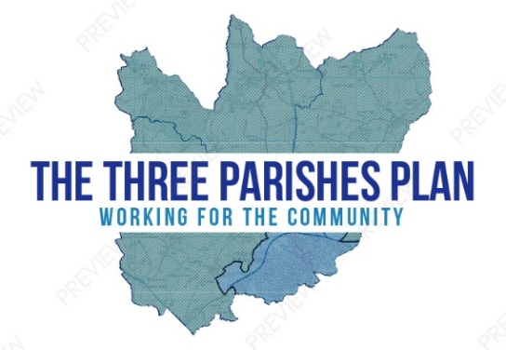
Three Parishes
Neighbourhood Plan
Communications Strategy

- Objectives
The overall objective of the Neighbourhood Plan (NP) is to allow people in the communities of Adderley, Moreton Say and Norton in Hales to determine their own future development.
The N P should be a popular process, with inclusivity at the heart of a democratic process of decision making.
Attempt full community consultation, where it was not been achieved before.
Make sure people don’t ‘fall through the net’ in neighbourhood plan (NP) consultations;
ie ensure the inclusion of all sectors of the community
Build a groundswell of support going into the final referendum.

- Principles

- We need a combined approach going out to people and inviting people to central meetings;
- Present the NP in bite-size chunks;
- Use local people for consultation and use local expertise, in conjunction with hiring outside advisors;
- Face to face conversation is the most effective method of communication
- Maintain an online presence, to save on resources;
- Use social media sensitively to promote events and attract comments
- As members of NP working groups, our own individual actions in informing people about the NP can be a useful check on the overall inclusivity of the NP.

- Message
Working For The Community
The N P is different to past plans because it will have the force of statutory law;
All future planning applications will have to comply with N P policies;
The N P can also be prescriptive ie what do we want for our parishes
The N P cannot prevent development but it can shape it.
- Audience
Our communities consist of:
Adderley Parish - population 372 of which:
Under 18s | 19.25% | *
Working Age Adults | 61.50% | *
Retirement Age | 19.25% | *
Moreton Say Parish - population 485 of which:
Under 18s | 20.25% | *
Working Age Adults | 66.10% | *
Retired Age | 13.65% | *
Norton in Hales Parish - population 620 of which:
Under 18s | 19.50% | *
Working Age Adults | 51.50% | *
Retired Age | 29.00% | *
* Information taken from the 11th Census

- Methods

Tool | Details | Who is Responsible | Frequency/Date | Target Audience
Community Events | Held in each parish in form of presentations, displays, open forum and face to face communication, collection of feedback | Steering Group of parish representatives | At key points in the process | Working age and retired adults
Neighbourhood Plan Champions | To attend local events to highlight and promote the Neighbourhood Plan and collect feedback | Steering Group of parish representatives | As required | All aged local residents
Website | A dedicated website regularly updated and with a forum for members of the public to provide feedback | Website administrator supported by Steering Group | News update every two weeks and before and after key events | Young people and all adult residents
Banners and leaflets | A pull-up banner and leaflets in each Parish located in the Village Hall | Parish Representatives on the Steering Group | Banner to be moved as required | Working age and retired adults

Tool | Details | Who is Responsible | Frequency/Date | Target Audience
Press Releases | Articles in Market Drayton Advertiser and Shropshire Star and on Radio Shropshire to regularly update and advertise key events | Steering Group of parish representatives | Regularly - at least monthly | Working age and retired adults
Church Magazines | Articles in AMICA, which covers Adderley and Moreton Say and Church magazine for Norton in Hales to advertise key events | Clerk and Steering Group of parish representatives | As required | Working age and retired adults
Surveys and Questionnaires | To be sent to all residents of the three parishes with return envelopes provided | Steering Group of parish representatives | When necessary | Local residents
Podcast surveys | To conduct a podcast survey and possibly drawing competition at all three village primary schools | Steering Group of parish representatives | When necessary | Primary school aged children
Social Media | Use of social media sites used within the Villages to be considered, including Rural Watch, to advertise key events | Steering Group of parish representatives | As required and with regularly updates | All aged local residents

Three Parishes Neighbourhood Plan
www.threeparishplan.org

Contact Jane Evans on:
clerk@adderleyparish.co.uk or 01630 654504

