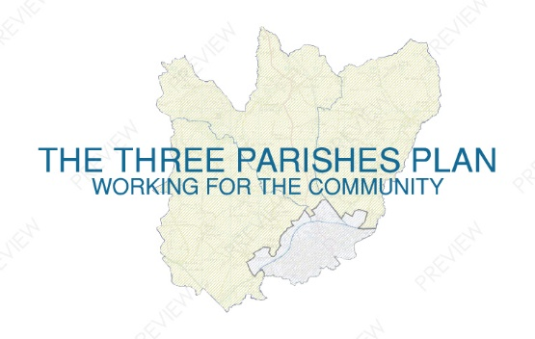
THREE PARISHES PLAN
The Neighbourhood Plan for
Adderley, Moreton Say & Norton-in-Hales parish Councils

Three Parishes Plan
c/o 51 Longford Turning, Market Drayton, TF9 3PF
Telephone: (01630) 654504 e-mail: clerk@adderleyparish.co.uk

